Important links
- Hyperlink for purchase/access of the National Formulary of India (NFI)
National Formulary of India (NFI) – 2021
- Drug Safety Alerts issued under the Pharmacovigilance Programme of India (PvPI)
Drugs Safety Alerts for Sensitisation of Healthcare Professionals - Indian Pharmacopoeia Commission
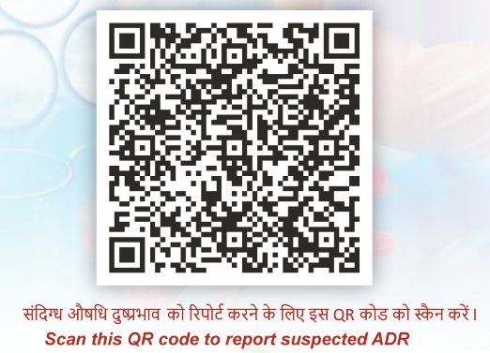
- QR Code of the ADR Monitoring System (ADRMS)

- List and details of Adverse Drug Reaction Monitoring Centres (AMCs) in the State
1150-AMC-Details.pdf
- Adverse Drug Reaction Reporting Form for Healthcare Professionals & ADR Reporting Form for Consumers in Hindi & other Vernacular Languages
ADR Reporting Forms - Indian Pharmacopoeia Commission

